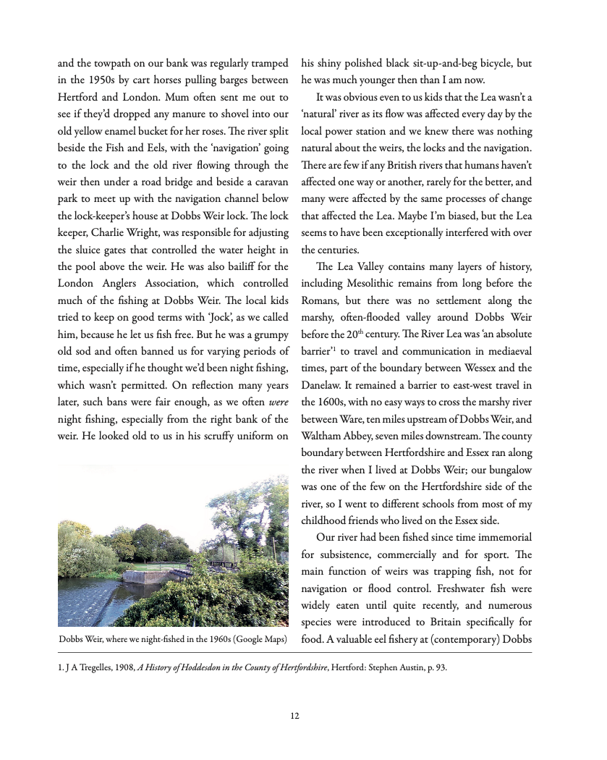

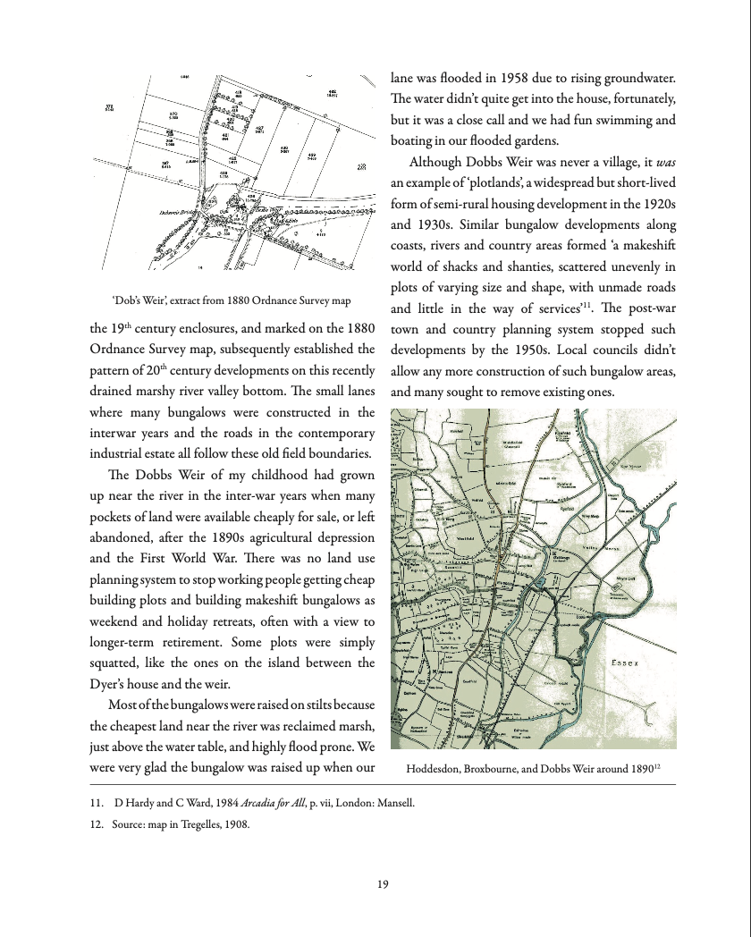

**Better version of the image on page 17**

